43.29: a) 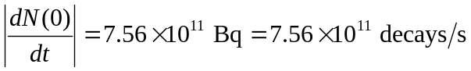
and
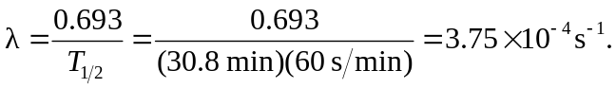
so
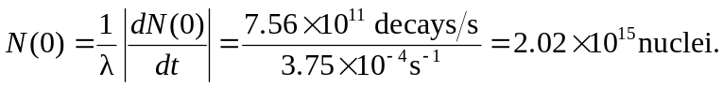
b) The number of nuclei left after one half-life is 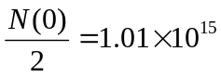 nuclei, and the activity is half: 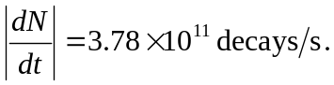
c) After three half lives (92.4 minutes) there is an eighth of the original amount 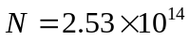 nuclei, and an eighth of the activity:
